***GitHub Tutorial for Final Project***

***Part 3***

1. What is GitHub? GitHub is an American company that provides hosting for software development version control using Git. Gitis a distributed version-control system for tracking changes in source code during software development. It is designed for coordinating work among programmers, but it can be used to track changes in any set of files. It provides [access control](https://en.wikipedia.org/wiki/Access_control) and several collaboration features such as [bug tracking](https://en.wikipedia.org/wiki/Bug_tracking_system), [feature requests](https://en.wikipedia.org/wiki/Software_feature), [task management](https://en.wikipedia.org/wiki/Task_management), and [wikis](https://en.wikipedia.org/wiki/Wiki) for every project.
2. When was it created? GitHub was originally founded in February 2008, by Chris Wanstrath, P. J. Hyett, Tom Preston-Werner and Scott Chaco. Although GitHub was founded in 2008, Git was created in 2005 as a better way to work on the open source software called Linux. The GitHub was created off this idea site where any other software project could operate much like the Linux project. It created a site the average coder could easily grasp. Microsoft eventually acquired GitHub in 2018 for a hefty price tag of $7.5 billion!
3. What similar platforms exist? There are many platforms that exist that are similar to GitHub. Some examples are: GitKraken, AWS CodeCommit, Cloud Source by Google, Apache Allura, Beanstalk, FogBugz Kiln, GitLab, & Bitbucket
4. Why would you use such a platform? (Answer between 2 and 3 lines). I would personally use a platform like GitHub for many reasons: 1) Showcase my work and present it to a potential employer in a resume 2) Contribute to open source projects I am a part of, or contribute to an existing project 3) Track any changes/bugs and fixes made to my code with new version updates

***Part 5: Git tutorial***

***Get Git: GitHub Desktop***



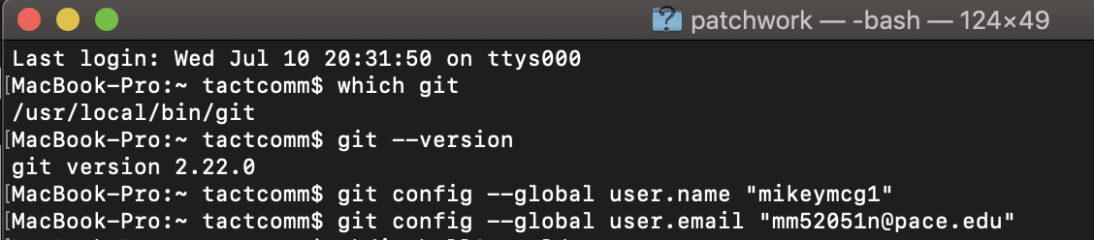

***Atom Text Editor***



***Git-it***

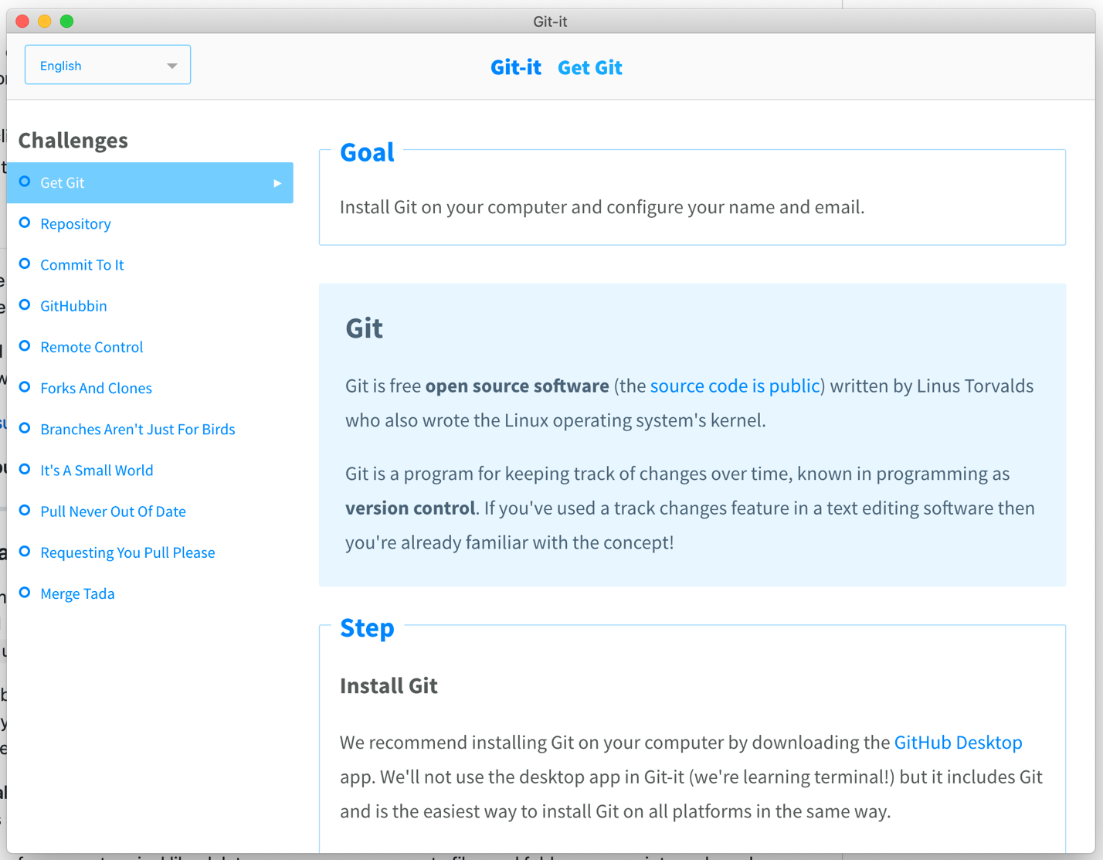

***Repository***

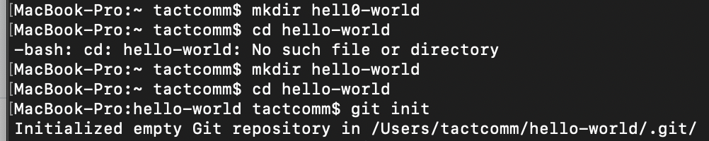

***Commit To It***

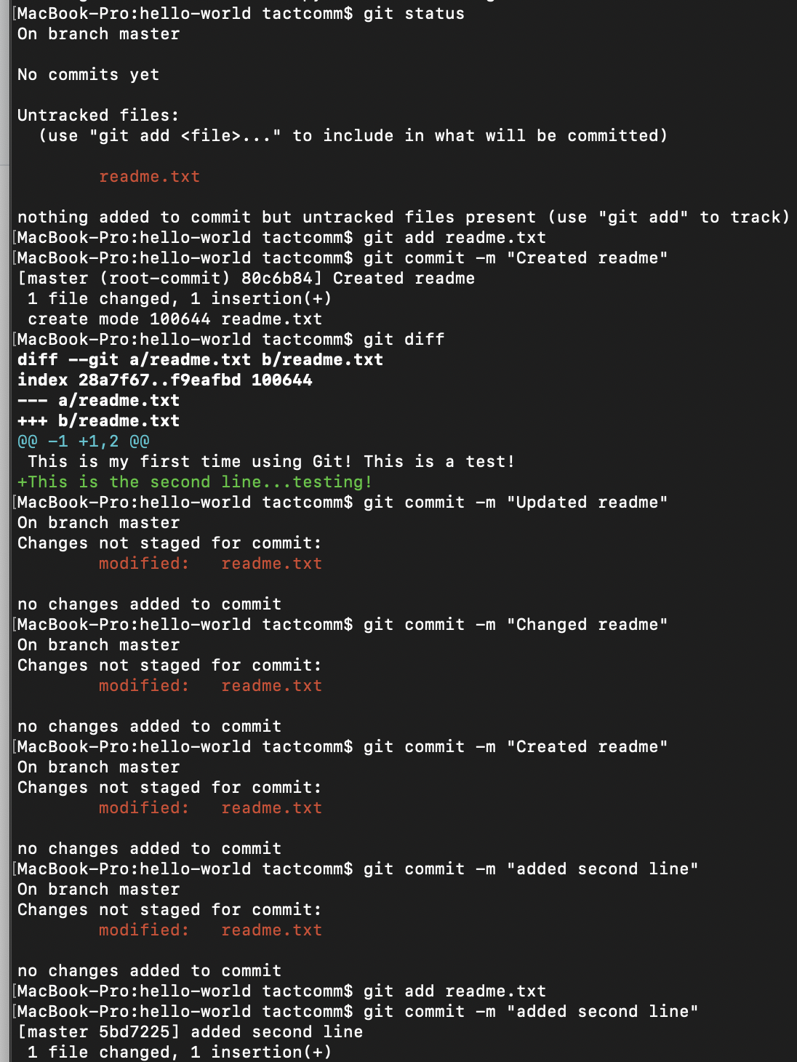

***GitHubbin***



***Remote Control Practice***



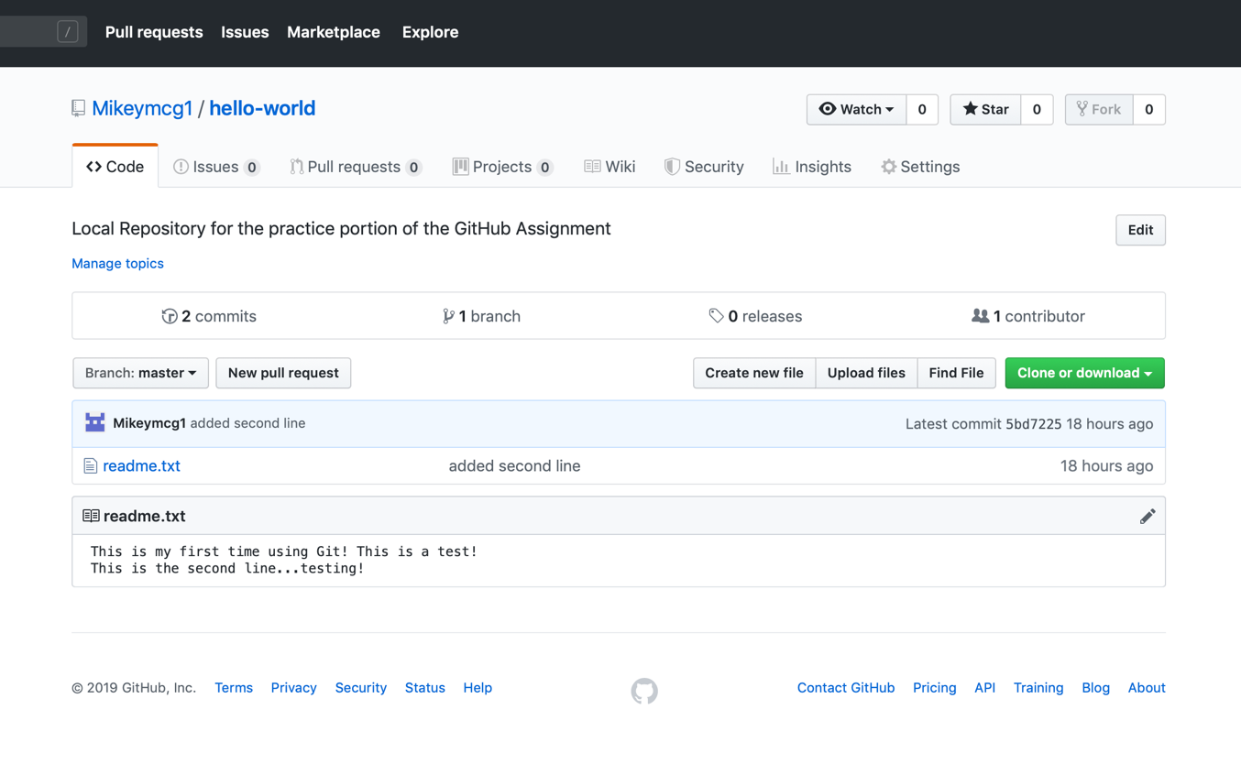

***Forks And Clones***



***Branches Aren’t Just For Birds***



***It’s A Small World***



***Pull Never Out Of Date***



***Requesting You Pull Please***



***Merge Tada***

